MRI GAUSS GUN OPTIMIZATION

A Thesis

Presented to

the Faculty of the Department of Electrical and Computer Engineering

University of Houston

in Partial Fulfillment

of the Requirements for the Degree

Master of Science

in Electrical Engineering

by

Mohammad M. Sultan

December 2017

MRI Gauss Gun Optimization

**_____________**

Mohammad M.Sultan

Approved:

**______________________**

Chairman of the Committee

Aaron T. Becker, Assistant Professor

Department of Electrical and Computer Engineering

Committee Members: **______________________**

Jack Wolfe, Professor

Department of Electrical and Computer Engineering

**______________________**

Jose Luis Contreras-Vidal, Professor

Department of Electrical and Computer Engineering

**______________________**

Nikolaos Tsekos, Associate Professor

Department of Computer Science

**_______________** **______________________**

Suresh K.Khatar, Assossiate Dean Badrinath Roysam, Professor Chair

Cullen College of Engineering Electrical and Computer Engineering

# **ACKNOWLEDGEMENTS**

First of all, I would like to express my utmost appreciation to Dr. Aaron T. Becker for his unwavering support and guidance throughout this journey. I would also like to mention that Dr. Becker is the driving force behind my decision to switch to the thesis path in the robotics field, as I was inspired by him after taking his robotics class. I want to thank Dr. Julien Leclerc, post-doctoral researcher at the Robotic Swarm Control Lab, for his valuable assistance in the FEMM software. A large thank you is due for Jarret Lonsford and Javier Garcia for their help in the experiments, and to everyone at the Robotic Swarm Control Lab for always providing me with their assistance when it was needed. Last but not least, my deepest gratitude goes to my parents, siblings and fiancée Tasneem for their constant encouragement and support in my attainment of this goal.

MRI Gauss Gun Optimization

An Abstract

of a

Thesis

Presented to

the Faculty of the Department of Electrical and Computer Engineering

University of Houston

in Partial Fulfillment

of the Requirements for the Degree

Master of Science

in Electrical and Computer Engineering

by

Mohammad M. Sultan

December 2017

# **ABSTRACT**

MRI-based navigation and propulsion of millirobots is a new and promising approach for minimally invasive therapies. The strong field inside the scanner, however, precludes torque-based control. Consequently, prior propulsion techniques have been limited to gradient-based pulling through fluid-filled body lumens. This thesis shows numerical analysis and results for optimizing the kinetic energy generated by the Gauss Gun to penetrate tissue, deliver a drug or remove a clot. This analysis based on the energy system of the MRI Gauss Gun. The numerical method used for this optimization is Nelder Mead method implemented in Mathematica software.

# **Table of Contents**

ACKNOWLEDGEMENTS iii

ABSTRACT v

Table of Contents vi

List of Figures viii

List of Tables xi

List of Samples xii

Introduction 1

Related Work 6

2.1 Penetration Tests 6

2.2 Self-Assembly Tests 7

2.3 Auto-Injectors 8

2.3.1 Definition 8

2.3.2 Design 8

2.3.3 Military use for Auto – Injectors 9

2.3.4 MRI Gauss Gun and Auto-Injector comparison 9

MRI Gauss Gun Force, Torque, Design, Materials and Energy System 10

3.1 Magnet Force Calculation inside MRI 10

3.2 Magnetic Torque on MRI Gauss Gun 12

3.3 MRI Gauss Gun Design 12

3.4 MRI Gauss Gun Materials 13

3.5 MRI Gauss Gun Magnetic Energy to Kinetic Energy 14

3.5.1 Kinetic and Potential Energies in MRI Gauss Gun System 14

3.5.2 Numerical and Analytical Methods using Mathematica 15

MRI Gauss Gun Optimization – Analytical and Numerical Results 18

4.1MRI Gauss Gun Restrictions 18

4.2 Analytical and Results 19

4.2.1 Numerical and Analytical Methods using Mathematica 19

4.2.2 Numerical Analysis when all millirobots have the same radii 20

4.2.3 Numerical Analysis using different radii when *N* = 1 and *N* = 2 24

4.3 Study Cases 27

4.3.1 Study Case 3: Designing MRI Gauss Gun for brachytherapy delivery in the bladder (limited radius size to insert each component, very large area to assemble). 27

4.3.2 Study Case 2: Designing MRI Gauss Gun for cyst fenestration in brain ventricle, entry through the spinal canal. 29

4.3.3 Study Case 3: Designing MRI Gauss Gun for clot removal case from the coronary artery. 31

Conclusion 34

References 35

# **List of Figures**

Figure 1.1 Operation of a Gauss Gun. (a) Standard design for use outside an MRI scanner shown before and after triggering. Magnetized spheres are green. Non-magnetized spheres are gray. (b) Design for use inside an MRI scanner shown before and after triggering. All spheres are magnetized when inside the scanner. See video at http://youtu.be/uJ4rFA8x2Js. 3

Figure 1.2 Brachytherapy seed which use to treat prostate cancer. 3

Figure 1.3 Fluid-filled spaces in the brain ventricle we can use MRI Gauss Gun to deliver a drug to help removing brain tumor. http://humananatomylibrary.com/anatomy-of-the-lateral-ventricle/anatomy-of-the-lateral-ventricle-anatomy-of-brain-ventricles-hu 4

Figure 1.4 MRI Gauss Gun to remove the clot from the coronary artery that causes the heart attack. This picture from https://www.nhlbi.nih.gov/health/health-topics/topics/heartattack 4

Figure 1. 5 Shows the bladder and the urinary system. https://biology.stackexchange.com/questions/56251/how-does-the-bladder-transition-from-releasing-urine-at-night-to-being-able-to-h 5

Figure 2.1 (a) MRI Gauss Gun components. (b) Cross-section, three components MRI Gauss Gun before and after firing. 6

Figure 2.2 Photos from an experiment within the MRI bore. The membrane model is a water balloon filled with dye. See the video attachment. T = Trigger D = Delivery B = Barrel. 7

Figure 2.3 Auto-Injector 8

Figure 3. 1 Contour lines show the force component radially outward from a sphere at (0,0) on an identical sphere in an MRI. The magnetic field is symmetric about the z-axis. 11

Figure 3. 2 3D shape for the magnetic field. 11

Figure 3.3 Three stages MRI Gauss Gun with all the components, (a) Trigger component, (b) Barrel component contains two stages and (c) Delivery component. 14

Figure 3.4 One stage MRI Gauss Gun contains only of (a) trigger component and (c) delivery component with no barrel component. 14

Figure 3. 5 shows how the energy system works in three stages MRI Gauss Gun (a) the trigger component is moving with _ini to the first stage from the MRI Gauss Gun, (b) trigger component hits the first stage with energy equals to , (c) the second millirobot from the first stage hits the first millirobot from the second stage with energy equals to , (d) the second millirobot from the second stage hits the first millirobot from the third stage with energy equals to and (e) the delivery part moves with energy . 18

Figure 4.1 MRI Gauss Gun with N = 3. 18

Figure 4. 2 kineticEnergy[r,N] function created in Mathematica to be used in MRI Gauss Gun optimization. 21

Figure 4.3 plot Vs for N from 1 to 10. Each curve represents a stage. The red dots represent the optimum value for each stage. 22

Figure 4.4 (a) Gauss Gun when N=1, (b) Gauss Gun when N=2, (c) Gauss Gun when N=3, (d) Gauss Gun when N=4, (e) Gauss Gun when N=5, (f) Gauss Gun when N=6, (g) Gauss Gun when N=7, (h) Gauss Gun when N=8, (i) Gauss Gun when N=9 and (j) Gauss Gun when N=10. 23

Figure 4.5 (a) Plot of Vs Vs , (b) Contour Plot for Vs , (c) Plot of Vs Vs and (d) Contour Plot forVs . While is the fired ball radius, is the fired millirobot in the first stage radius and is the second 25

Figure 4.6 (a) one stage optimum MRI Gauss Gun with different radii case and (b) two stages optimum MRI Gauss Gun with different radii case. 27

Figure 4.7 Mathematica code to find the optimum value for and to optimize 28

Figure 4. 8 Optimized MRI Gauss Gun to fit inside the bladder 28

Figure 4.9 Shows the MRI Gauss Gun inside the bladder 29

Figure 4.10 Mathematica code to find the optimum value for a,s and N to optimize KE. 30

Figure 4.11 Mathematica code to find the optimum value for a,s and N to optimize KE. 30

Figure 4.12 Optimized Gauss Gun with N = 4. 30

Figure 4.13 Shows the MRI Gauss Gun inside the lateral ventricle https://veteriankey.com/cerebrospinal-fluid-and-the-blood-brain-barrier/. 31

Figure 4.14 Mathematica code to find the optimum value for to optimize . 32

Figure 4.15 Leg groin area. https://www.epainassist.com/pelvic-pain/groin-pain. 32

Figure 4.16 Aorta Anatomy. http://www.jems.com/articles/print/volume-41/issue-3/features/how-aortic-aneurysms-become-aortic-catastrophes.html. 33

# **List of Tables**

Table 4.1 represents the optimum value in each stage from N = 1 to 10 24

Table 4.2 Shows the red points values in Figure 4.4. 26

Table 4.3 Shows the optimum values for *r, r*1*, r*2*, r*3*, r*4*, s, a* and *KE* when *L=1*. 26

Table 4.4 CT scan measurements (mean standard deviation) of frontal horn of lateral ventricle. https://www.researchgate.net/publication/268449358_Age-related_changes_in_ventricular_system_of_brain_in_normal_individuals_by_computed_tomography_scans 29

# List of Samples

air gap.

**d:** is the distance separating the two spheres with radii’s and .

**:** is the kinetic energy that the fired millirobot gains by the attraction force causes from the first millirobot when it getting close to it in the first stage.

**:** is the kinetic Energy that the millirobot gains by the attraction force causes from the first millirobot in the next stage when it moves distance from current stage to the next stage.

**:** final Kinetic energy.

MRI Gauss Gun Length.

**MRI:** Magnetic Resonance Imaging.

**:** is the magnetic saturation inside MRI = .

total barrel and delivery components.

is the potential energy between any two millirobots inside each stage before firing.

millirobot radius.

non-magnetic spacer.

the torque

vacuum permeability which is equal to V.s/(A.m).

**Chapter 1**

# **Introduction**

In general, there are three small scales robots millirobots, microrobots and nanorobots. Millirobots are robots having dimensions typically less than a centimeter [1], microrobots are robots with dimensions less than 1 mm while nanorobots are robots whose components are at or near the scale of a nanometer. In this thesis, we are interested in millirobots and it is applications

Millirobots have the potential to provide highly localized therapies with minimal trauma by navigating through the natural fluid-filled passageways of the body. While navigation, e.g., the circulatory system or cerebrospinal fluid spaces, is sufficient for some applications, it can also be necessary to penetrate into the surrounding tissue. Potential applications include puncturing a membrane to release trapped fluid, opening a blocked passageway, delivering a drug to a tissue location several centimeters from a fluid-filled space or brachytherapy Figure 1.4 shows the brachytherapy seed which use to treat prostate cancer.

The forces required for tissue penetration, however, are substantially higher than those needed to propel a millirobot through a bodily fluid and consequently can be difficult to achieve. Prior tether less systems for moving through tissue have relied on magnetic forces and torques produced by large external magnets to either pull magnetic spheres through brain tissue [2] or to rotate threaded magnetic cylinders through muscle tissue [3].

Alternatively, methods for tether less robot propulsion and control have been developed that employ the magnetic gradients of clinical MRI scanners [4] –[7]. MRI also provides the capability to image both the robot and surrounding tissue to guide navigation. MRI-based millirobot navigation in the vasculature was first demonstrated in [4]. Recently, algorithms enabling the simultaneous MRI-based control of multiple millirobots [5], [8] and macro-scale rotary actuators [6], [7] have also been developed.

Until now, however, the motion of MRI-powered millirobots has been constrained to fluid-filled spaces since the magnetic gradients produced by the scanner are relatively weak. The maximum gradient produced by most clinical scanners is in the range of 20-40mT/m producing a force on a magnetized steel particle equal to 36-71% of the gravitational force. While it is possible to install custom high-strength gradient coils, such as 400mT/m coil reported in [8], this approach is costly and can reduce the size of the MRI bore. While to facilitate motion within a fluid, a millirobot can be designed to be neutrally buoyant, the force magnitude produced by the magnetic gradient is not capable of producing tissue penetration.

Consider for example, that a standard 18 gauge needle requires 0.59 0.11N of force to penetrate 10mm into muscle tissue [10]. Bioinspired design can somewhat reduce these forces, e.g., the backward-tipped barbs of the North American porcupine quill exhibit forces of 0.33 0.08N for 10mm of muscle penetration [10]. Nevertheless, to reproduce even these forces using an MRI with a steel needle would require 3.3m long shaft – longer than the bore of the scanner. While the size of macro-scale MRI-based actuators permits the use of gear transmissions to trade off velocity and force [5], [11], this approach is not feasible at the millimeter scale. Therefore, to address the challenge of MRI-based tissue penetration, an alternative to gradient – based force production is needed.

The concept, illustrated in Figure 1.2, corresponds to a Gauss Gun [13],[14]. Comprised of one or more stages, each stage is composed of a strong magnet, followed by two or more steel spheres (bearing balls). By colliding a single steel sphere with the first magnet, a chain reaction is initiated, greatly amplifying the speed of the first sphere

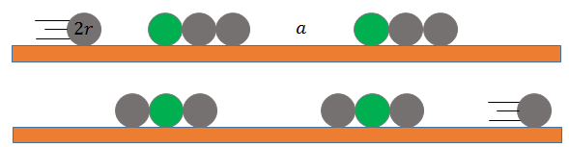

(a) Traditional Gauss Gun before and after triggering

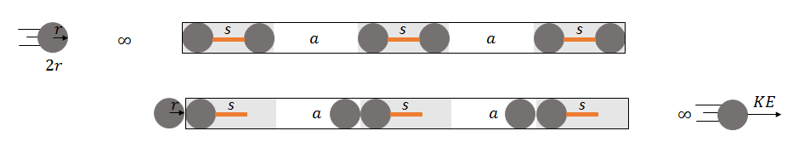

(b) MRI Gauss Gun before and after triggering

Figure 1.1 Operation of a Gauss Gun. (a) Standard design for use outside an MRI scanner shown before and after triggering. Magnetized spheres are green. Non-magnetized spheres are gray. (b) Design for use inside an MRI scanner shown before and after triggering. All spheres are magnetized when inside the scanner. See video at http://youtu.be/uJ4rFA8x2Js.

In an MRI scanner there is no need for permanent magnets, since steel is highly magnetized by 3T magnetic field of an MRI. Each stage contains two magnetized spheres separated by a nonmagnetic spacer, in individually stable. Using existing control approaches [5], [7], they can be navigated through fluid-filled spaces and self-assembled at a desired penetration location. The assembly can then be fired by a special trigger module consisting of two spheres separated by a spacer longer than that used in the individual stages. After firing, the assembly can be navigated out of the body. Figure 1.2, Figure 1.3, Figure 1.4 and 1.5 show where we can have potential application for MRI Gauss Gun.

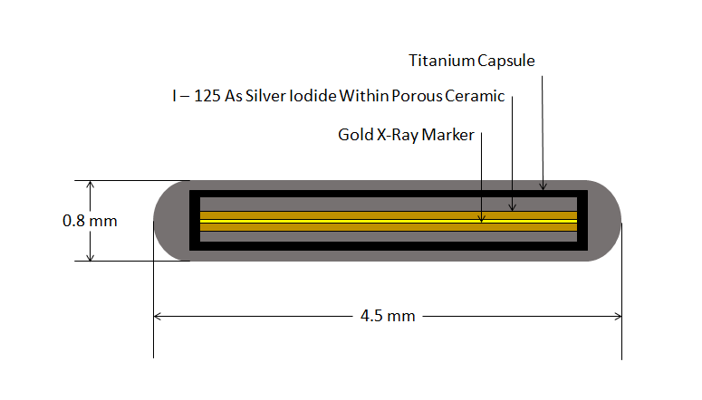

Figure 1.2 Brachytherapy seed which use to treat prostate cancer.

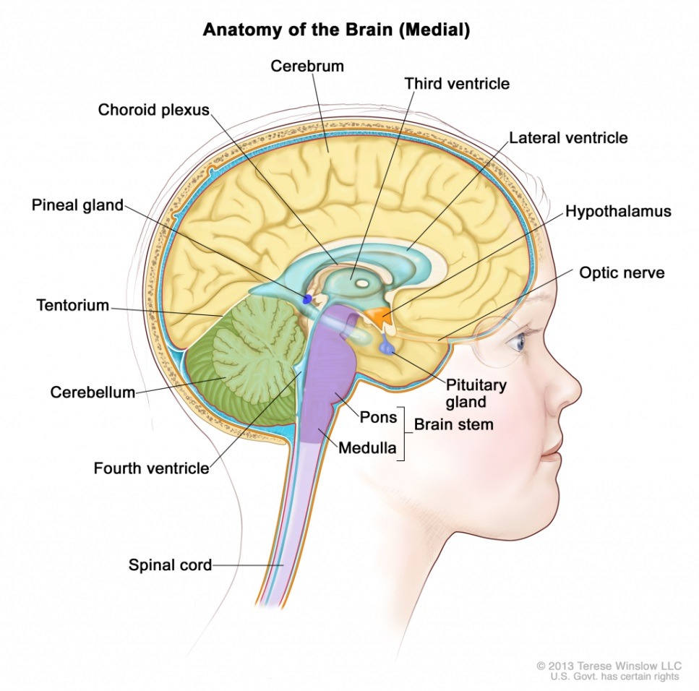

Figure 1.3 Fluid-filled spaces in the brain ventricle we can use MRI Gauss Gun to deliver a drug to help removing brain tumor. http://humananatomylibrary.com/anatomy-of-the-lateral-ventricle/anatomy-of-the-lateral-ventricle-anatomy-of-brain-ventricles-hu

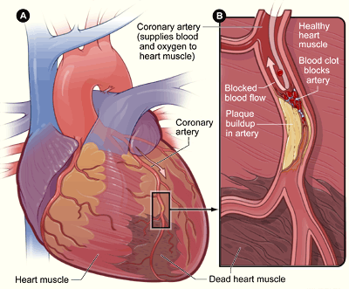

Figure 1.4 MRI Gauss Gun to remove the clot from the coronary artery that causes the heart attack. This picture from https://www.nhlbi.nih.gov/health/health-topics/topics/heartattack

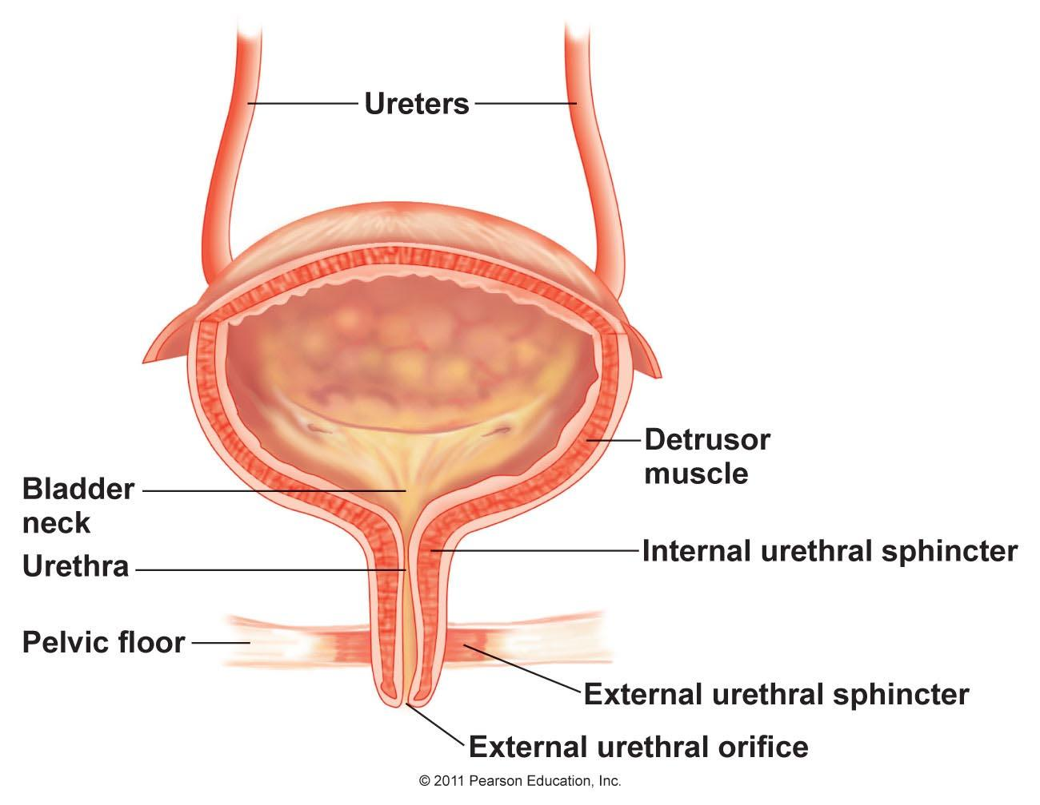

Figure 1. 5 Shows the bladder and the urinary system. https://biology.stackexchange.com/questions/56251/how-does-the-bladder-transition-from-releasing-urine-at-night-to-being-able-to-h

The next chapter shows related work done in MRI clinic. The third chapter explains the force, the torque and the energy inside MRI Gauss Gun also the design and the material used for design. Chapter four discusses numerical, Analytical and study cases for the MRI Gauss Gun. The last chapter is the conclusion of this work and possible future work.

**Chapter 2**

# **Related Work**

The MRI Gauss Gun components as in Figure 2.1 Were tested in a Siemen’s Skyra 3T clinical MRI scanner. Experiments tested penetration depth as a function of needle size and the ability of components to self-assemble.



(a)



**(b)**

Figure 2.1 (a) MRI Gauss Gun components. (b) Cross-section, three components MRI Gauss Gun before and after firing.

## 2.1 Penetration Tests

Several experiments were conducted to test the ability of the MRI-Gauss gun at tissue penetration. The tests use a brain model composed of a solidified 0.5% agarose gel solution [19]. A 30mm block of agarose was used and placed near the isocenter of a Siemen’s Skyra 3T MRI scanner. The delivery component, loaded with either an 18, 20, or 26-gauge needle was placed against the solution. Zero, one or two barrel components were attached, and the trigger component was then manually pushed toward the assembled Gauss gun. Needle penetration was measured using a plastic ruler mounted underneath the transparent agar solution.

The experiments results are represented in Figure 2.2 Five trials were recorded for each needle size. The penetration distance increases as the gauge increases (needle diameter decreases).

## 2.2 Self-Assembly Tests

Figure 2.2 shows photos from two experiments with MRI Gauss Gun assembly and membrane penetration. The experiments were performed under MRI control, using gradients in the x and z-direction of_23mT/m. The workspace was a plastic toolbox (McMaster-Car 8704T73) filled with water. The Gauss gun components were mounted on floats and colored green to increase visibility. Three tests were performed, and are included in the video attachment. The first two experiments each used a delivery and a trigger component and fired 18-gauge needle tips welded to 1mm spheres into a membrane model, a water balloon filled with blue dye. The third experiment tested ranged delivery, by firing the needle projectile using a delivery, barrel, and trigger component to penetrate a membrane model from a distance of 240 mm.

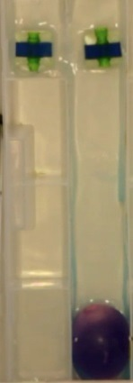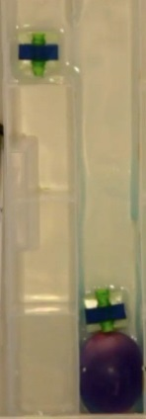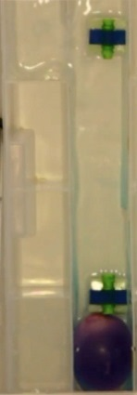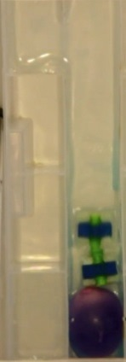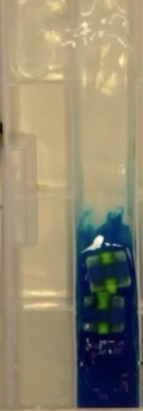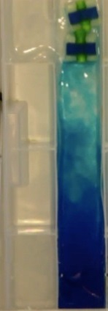

**T**

**D**

**T**

**T**

**D**

**D**

**D**

**T**

**D**

*z*

**D**

*x*

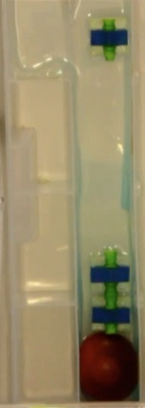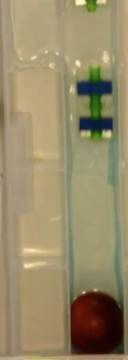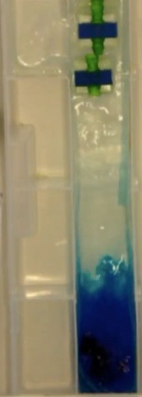

**T**

**T**

**T**

**B**

**D**

**B**

**D**

**B**

**D**

(a) Membrane puncture, two components (b) Membrane puncture three components

Figure 2.2 Photos from an experiment within the MRI bore. The membrane model is a water balloon filled with dye. See the video attachment. T = Trigger D = Delivery B = Barrel.

## 2.3 Auto-Injectors

### 2.3.1 Definition

An auto-injector is a medical device designed to deliver a dose of a particular drug. Most auto-injectors are spring-loaded syringes. By design, auto-injectors are easy to use and are intended for self-administration by patients, or administration by untrained personnel. The site of injection depends on the drug loaded, but it typically is administered into the thigh or the buttocks. The injectors were initially designed to overcome the hesitation associated with self-administration of the needle-based drug delivery device [30].

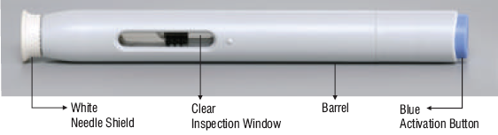

Figure 2.3 Auto-Injector

### 2.3.2 Design

The auto-injector keeps the needle tip shielded prior to injection and also has a passive safety mechanism to prevent accidental firing (injection). Injection depth can be adjustable or fixed and a function for needle shield removal may be incorporated. Just by pressing a button, the syringe needle is automatically inserted and the drug is delivered. Once the injection is completed some auto injectors have the visual indication to confirm that the full dose has been delivered. Auto-injectors contain glass syringes, which can make them fragile and contamination can occur. More recently, companies have been looking into making auto-injector syringes out of plastic to prevent this issue [30].

### 2.3.3 Military use for Auto – Injectors

Auto-injectors are often used in the military to protect personnel from chemical warfare agents. In the U.S. military, atropine and 2-PAM-Cl (pralidoxime chloride) are used for first aid ("buddy aid" or "self-aid") against nerve agents. An issue item, the Mark I NAAK (Nerve Agent Antidote Kit), provides these drugs in the form of two separate auto-injectors. A newer model, the ATNAA (Antidote Treatment Nerve Agent Auto-Injector), has both drugs in one syringe, allowing for the simplification of administration procedures [30].

### 2.3.4 MRI Gauss Gun and Auto-Injector comparison

Both MRI Gauss Gun and auto-injector can be used for drug delivery with two main differences, the needs for MRI and the energy source. MRI Gauss Gun needs MRI to work while the auto-injector doesn’t need it. The MRI Gauss Gun energy source is the Gauss Gun while the auto-injector energy source is the spring.

**Chapter 3**

# **MRI Gauss Gun Force, Torque, Design, Materials and Energy System**

## 3.1 Magnet Force Calculation inside MRI

Ferrous material placed inside the MRI scanner becomes a strong magnetic dipole. The gradient fields can then apply forces on these dipoles. The dipoles exert forces on each other.

The magnetic field at position generated by a spherical magnet at position with magnetic moment is

(3.1),

while (3.2). This is the magnetic of a dipole.

The force applied to a dipole at with magnetic moment by another dipole at with magnetic moment is approximated by

(3.3)

The torque applied on a dipole at by a dipole at is

(3.4)

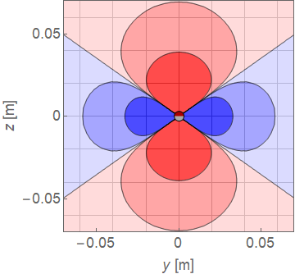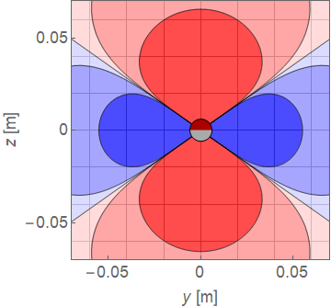

mm

Figure 3. 1 Contour lines show the force component radially outward from a sphere at (0,0) on an identical sphere in an MRI. The magnetic field is symmetric about the z-axis.

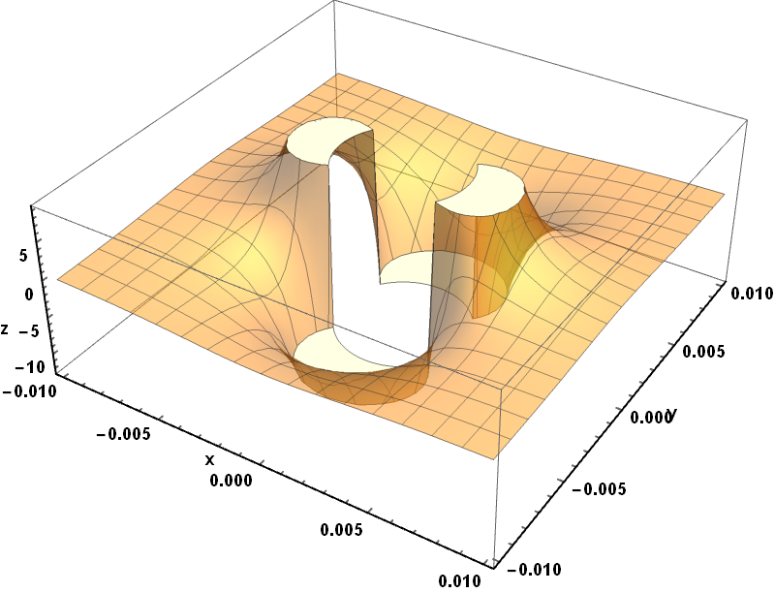

Figure 3. 2 3D shape for the magnetic field.

Inside a 3T MRI, a steel sphere becomes fully magnetized with magnetic saturation   
.

The magnetic moment of a sphere with radius is aligned with the MRI field:

(3.5)

Figure 3.1 shows contour plots for the magnetic force exerted by two identical spheres on each other. The contour lines show , the force component radially outward from the sphere at (0,0) compared to the maximum force provided by the gradient coils . This force is attractive (red) along the z-axis and repulsive (blue) perpendicular to -axis. The magnetic field is symmetric about the z-axis. If two spheres move within the dark red region, they cannot be separated using the gradient field. The contour lines are drawn at = The maximum force is along the z-axis is

(3.6)

d: is the distance separating the two spheres with radii’s and .

: is the magnetic saturation inside MRI = .

vacuum permeability which is equal to V.s/(A.m).

## 3.2 Magnetic Torque on MRI Gauss Gun

Because each Gauss Gun component has two ferrous spheres, the MRI field creates a torque that acts to line the components parallel to the z-axiz. Applying (3.4), with magnetic moments given by (3.5), on a component with spheres radii’s and , separated by , and the line between the spheres at an angle of from , generates the restoring torque:

(3.7)

This torque increases by increasing and/or and decreasing . This torque results in stable equilibrium configurations pointing along the *z*-axis and unstable equilibriums perpendicular to the axis. The stable equilibriums correspond with maximum attractive force between the spheres, and the unstable equilibriums with maximum repulsive force. The average torque on the spheres is the average force between the spheres.

## 3.3 MRI Gauss Gun Design

This section shows the MRI Gauss Gun design and how it differs from the traditional Gauss Gun. MRI Gauss Gun contains three components: trigger component, barrel component and the delivery component, knowing that the number of stages *N* is the number stages in the barrel component and delivery component.

* Trigger component: This component is important to fire the Gauss Gun. Part (a) in Figure 3.2 represents the trigger component
* Barrel component(optional): is the middle stage(s) between the firing and delivery components, each stage has two spheres each sphere with radius with a non-magnetic spacer between the spheres, and between any two stages there is air gap which greater than the spacer , which necessary to the magnetized sphere to be released from own stage when firing. The barrel component used to achieve stronger forces. Part (b) in Figure 3.2 represents the barrel component. Figure 3.3 shows the case when there is no barrel component.
* Delivery component: one stage contains two spheres each sphere with radius with a non-magnetic spacer between the spheres, we can replace the delivery sphere to deliver a drug. While the delivery component used to administer the desired treatment or a drug delivery. Part (c) in Figure 3.2 represents the delivery component.

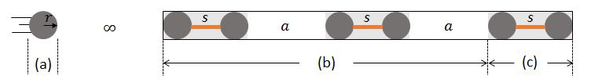

Figure 3.3 Three stages MRI Gauss Gun with all the components, (a) Trigger component, (b) Barrel component contains two stages and (c) Delivery component.

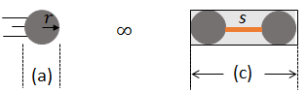

Figure 3.4 One stage MRI Gauss Gun contains only of (a) trigger component and (c) delivery component with no barrel component.

## 3.4 MRI Gauss Gun Materials

In this thesis the MRI Gauss Gun uses steel spheres (E52100 Alloy, McMaster 992K41) for the magnets and shaped rods of nonmagnetic metal for spacers , which provides several benefits:

* Inside MRI, steel is a stronger magnet then neodymium
* Spacer length is arbitrary and can be chosen to maximize energy
* Leaving multiple magnets in tissue is potentially dangerous, leading, e.g., to bowel necrosis, perforation, volvulus, sepsis, and possible death [17][18]. In contrast, the steel bearing ball using in this thesis lose their magnetism when removed from the magnetic field.
* MRI enables imaging and control to assemble components at target.
* MRI enables controlled removal of components.

## 3.5 MRI Gauss Gun Magnetic Energy to Kinetic Energy

This section investigates how the energy system works in the MRI Gauss Gun. MRI Gauss Gun has *N* stages, each stage has two spheres each with radius *r* between them nonmagnetic spacer *s.* and between each two stages there is air gap *a.*

Before firing the system is stable, each stage has Potential Energy and this energy needed to break the magnetic bond between them to release the millirobot from each stage. In 3.5.1 are the details for all kinetic and potential energies in MRI Gauss Gun system.

### 3.5.1 Kinetic and Potential Energies in MRI Gauss Gun System

This part of section 3.5 shows all the energies that form in MRI Gauss Gun. Notice that this section ignores the heat, fraction and any mechanical losses.

* is the potential energy between any two millirobots inside each stage before firing, which is the same energy needed to break the magnetic bond between any two millirobots inside each stage. to find this energy we need to find the negative integration of in equation (3.6) which is:

(3.8)  
 (3.9)

* : is the kinetic energy that the fired millirobot gains by the attraction force causes from the first millirobot when it getting close to it in the first stage.

We can find this kinetic energy using the following equations:

(3.10)  
 (3.11)  
Now from (3.6), (3.10) and (3.11) then

(3.12)

Assuming that the constant *C* includes all the terms except the distance between the spheres, and after doing the integration:

(3.13)

* : is the kinetic Energy that the millirobot gains by the attraction force causes from the first millirobot in the next stage when it moves distance from current stage to the next stage.

Using equations (3.6), (3.10) and (3.11):

(3.14)

(3.15)

(3.16)

### 3.5.2 Numerical and Analytical Methods using Mathematica

In this part of section 3.5 is the energy system mechanism inside the MRI Gauss Gun and the derivation formula for the delivery component kinetic energy.

Before firing the barrel and delivery components are stable as in Figure 3.4 (a), each stage in these components has potential energy and this energy needed to break the magnetic bond between them to release the millirobot from each stage. From there we can find that the system has energy losses equals to a number of stages times the potential energy. Equation (3.17) shows the energy losses in the system.

(3.17)

After firing the trigger millirobot will hit the first millirobot in the first stage as in Figure 3.4(b) which represents the impact between the trigger component and the barrel component, in the impact step, transfer to the first stage, since is greater than , that will break the magnetic bond in the first stage and will release the second ball from the first stage with energy equals to as in Figure 3.4 (c).

Then the released millirobot will start getting impact by the attractive force from the first ball in the second stage which will gain the released millirobot with J and then the resulting energy will transfer to the next stage as in Figure 3.4 (d).

This process will keep going until the millirobot received to the last stage to release the delivery component, which will gain kinetic energy as in equation (3.18) which shows the final kinetic energy that the delivery component released with when the MRI Gauss Gun has Stages.

(3.18)

(3.19)

(3.20)

Note that when which means no barrel component then the final kinetic energy equals to the following equation:

(3.21)

Figure 3.4 explains how the energy transfers inside three stages MRI Gauss Gun until it reaches the delivery part. You can apply the same idea to *N* stages MRI Gauss Gun.

for Figure 3.4 is as the following:

(3.22)

(3.23) 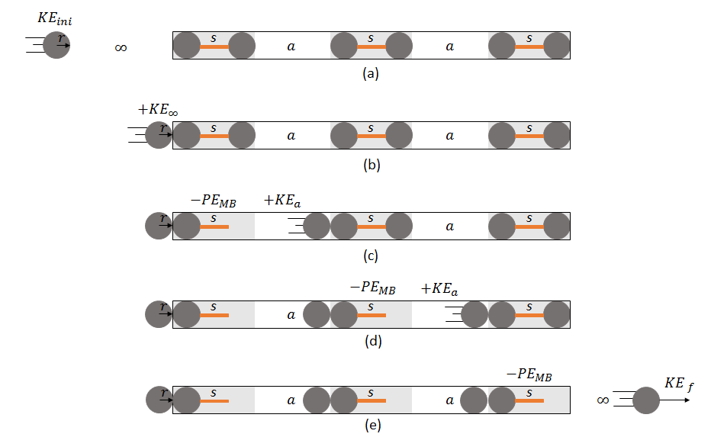

Figure 3. 5 shows how the energy system works in three stages MRI Gauss Gun (a) the trigger component is moving with _ini to the first stage from the MRI Gauss Gun, (b) trigger component hits the first stage with energy equals to , (c) the second millirobot from the first stage hits the first millirobot from the second stage with energy equals to , (d) the second millirobot from the second stage hits the first millirobot from the third stage with energy equals to and (e) the delivery part moves with energy .

**Chapter 4**

# **MRI Gauss Gun Optimization – Analytical and Numerical Results**

## 4.1MRI Gauss Gun Restrictions

In this thesis we are interested in the MRI Gauss Gun length restriction *L*, consider we have MRI Gauss Gun with length *L* in which *L* includes all the components of the Gauss Gun as in Figure 4.1.

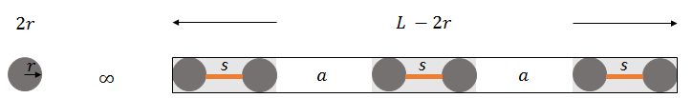

Figure 4.1 MRI Gauss Gun with N = 3.

The following equation represents *L* as expressed in Figure 4.1:

(4.1)

This *L* is the first restriction, and the second restriction we have is the air gap *a* between any two stages should be greater than the spacer *s* between any two spheres inside each stage.

From equation (4.1) we can notice that directly proportional with , and for whatever *N* value, this directly proportional will help us non-dimensionalized the optimization.

Recall equation (3.10) (3.10)

The third restriction the design has is the millirobot radius, which we will discuss in section 4.3, while section 4.2 will analyze the optimization for the first and second restrictions only.

## 4.2 Analytical and Results

### 4.2.1 Numerical and Analytical Methods using Mathematica

Here, we are trying to maximize KE with the restriction L, from equation (3.10) we notice that it is non-linear equation, to optimize it, we used Mathematica software which has four different Numerical Algorithms for constrained global optimization:

* **Differential Evolution:** is a simple stochastic function minimizer. The algorithm maintains a population of m points, {, ……, }, where typically m>>n, with n being the number of variables. This method is computationally expensive, but relatively robust and tends to work well for problems that have more local minima [11].
* **Nelder Mead:** it is a direct search method. For a function of *n* variables, the algorithm maintains a set of *n+1*points forming the vertices of a polytope in *n*-dimensional space. This method is often termed the "simplex" method, which should not be confused with the well-known simplex method for linear programming [11].
* **Random Search:** it works by generating a population of random starting points and uses a local optimization method from each of the starting points to converge to a local minimum. The best local minimum is chosen to be the solution [11].
* **Stimulated Annealing:** a simple stochastic function minimizer. It is motivated from the physical process of annealing, where a metal object is heated to a high temperature and allowed to cool slowly. The process allows the atomic structure of the metal to settle to a lower energy state, thus becoming a tougher metal. Using optimization terminology, annealing allows the structure to escape from a local minimum, and to explore and settle on a better, hopefully global, minimum [11].

In this optimization, we tried all methods, and we found the following:

Random search and Differential Evolution work for single point but they don’t work when I use them in plot function, Stimulated Annealing and Nelder Mead optimization methods both works with plot function but the later method is much faster than Stimulated Annealing that is why we chose Nelder Mead in this optimization.

In our research the goal is to optimize KE in (3.10) using Nelder Mead Method for different N values for two cases:

Case 1: when all millirobots have the same radii, this we be discussed in 4.2.2.

Case 2: when millirobots have different radii for *N* = 1 and *N* = 2, this case will be discussed in 4.2.3.

### 4.2.2 Numerical Analysis when all millirobots have the same radii

This part will show the optimization to find the optimum KE for the case when all millirobots have the same radii, Figure (4.1) shows the kineticEnergy[*r,N*] function created using Mathematica to find the optimum kinetic energy for the delivery millirobot given radius *r* and number of stages *N*.

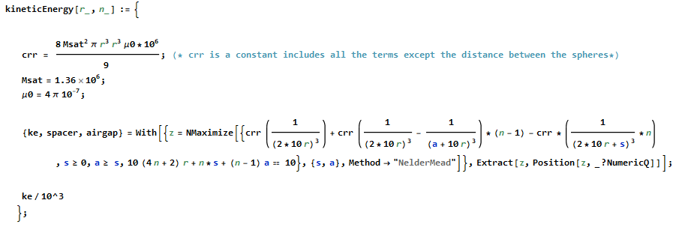

Figure 4. 2 kineticEnergy[r,N] function created in Mathematica to be used in MRI Gauss Gun optimization.

The function in Figure 4.2 used to plot Vs *r/L* for *N* from 1 to 10, KineticEnergy[r,N] function used to plot Figure 4.3 and also used to find the optimum value for each parameter as in Table 4.1.

Figure 4.3 represents the plot Vs *r/L* for *N* from 1 to 10. In this plot, there are ten curves each curve represents the number of stages the MRI Gauss Gun has starting from one stage to ten stages, the red point on each curve represents the optimum KE value for each curve.

This plot has non-dimensionalized axes, you can use it for any *L* value, for instance, if at *r/L=* 0.143 when *N* = 1 is 1664.6 J thus for *L* =10 mm, *r* will equal 1.43 and KE will equal 166.46 J. In section 4.4 we will show some study cases using Table 4.1 and Figure 4.3

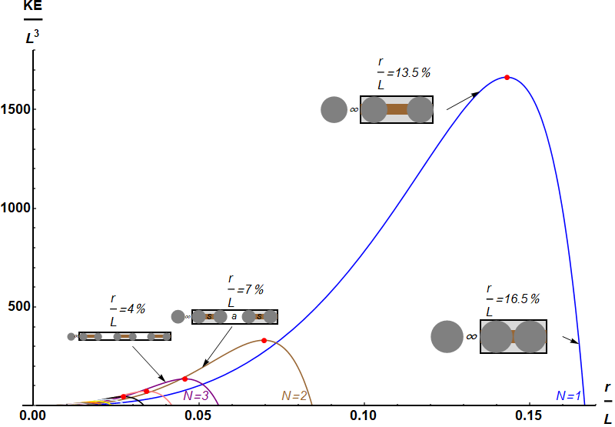

Figure 4.3 plot Vs for N from 1 to 10. Each curve represents a stage. The red dots represent the optimum value for each stage.

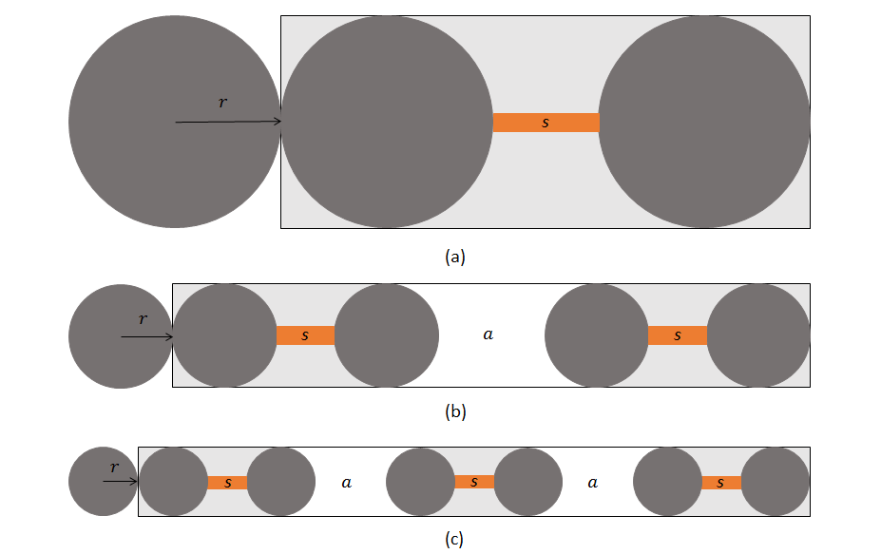

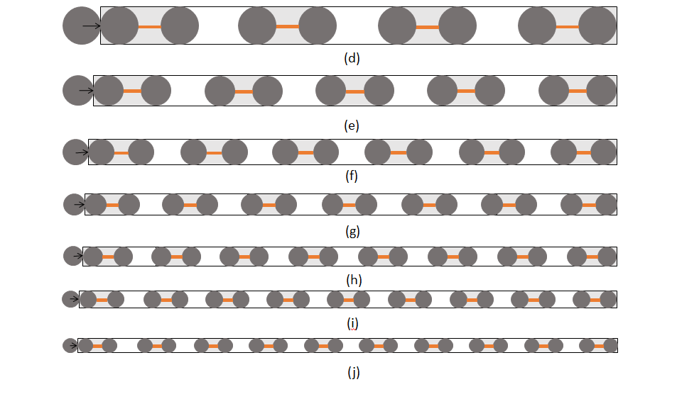

Figure 4.4 (a) Gauss Gun when N=1, (b) Gauss Gun when N=2, (c) Gauss Gun when N=3, (d) Gauss Gun when N=4, (e) Gauss Gun when N=5, (f) Gauss Gun when N=6, (g) Gauss Gun when N=7, (h) Gauss Gun when N=8, (i) Gauss Gun when N=9 and (j) Gauss Gun when N=10.

|  |  |  |  |  |
| --- | --- | --- | --- | --- |
|  |  | *s/L* | *a/L* |  |
| 1 |  |  |  |  |
| 2 |  |  |  | 331.5 |
| 3 |  |  |  | 135.7 |
| 4 |  |  |  | 73.2 |
| 5 |  |  |  | 45.6 |
| 6 |  |  |  | 31.1 |
| 7 |  |  |  | 22.6 |
| 8 | 0.017 | 0.021 | 0.037 | 17.1 |
| 9 | 0.015 | 0.018 | 0.033 | 13.4 |
| 10 | 0.013 | 0.017 | 0.03 | 10.8 |

Table 4.1 represents the optimum value in each stage from N = 1 to 10

Next section shows the optimization when the MRI Gauss Gun millirobots have different radii

### 4.2.3 Numerical Analysis using different radii when *N* = 1 and *N* = 2

4.2.1 showed the optimization for the situation when we have Length restriction with equal millirobot radii, in 4.2.2 we will show what will be the radii’s values when we give the optimization the freedom to optimize for different *r* values when *N* = 1 and *N = 2* using Nelder Mead method.

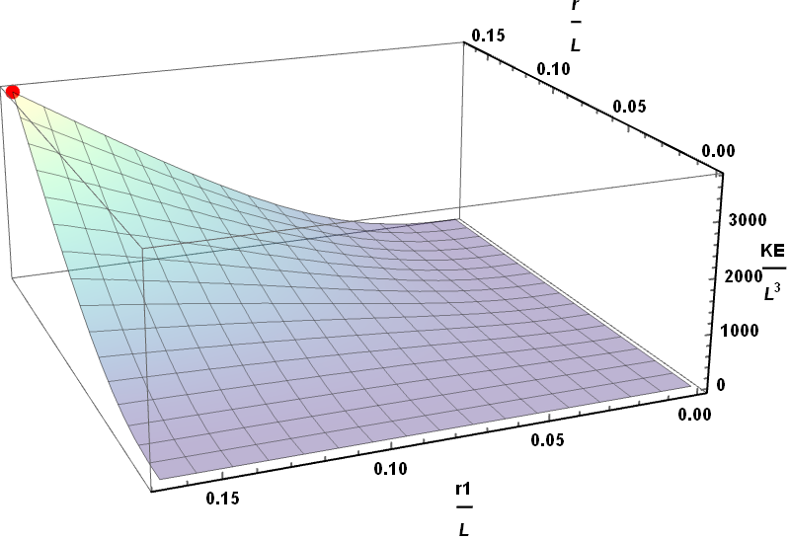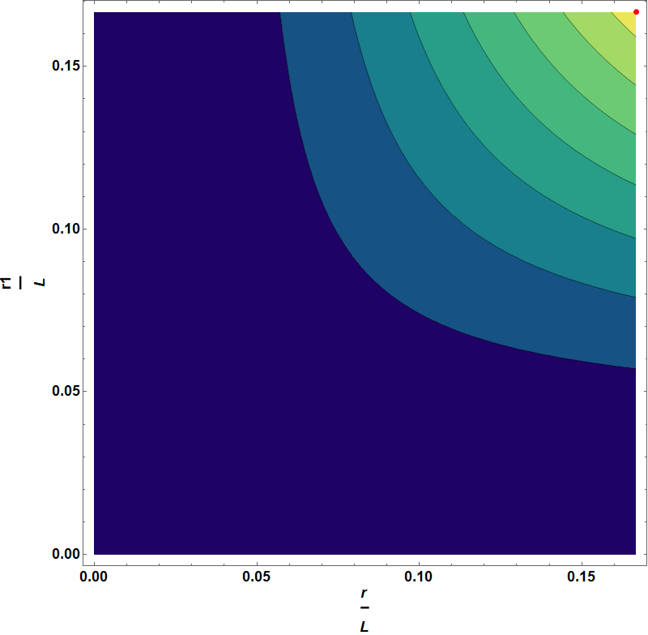

(a) (b)

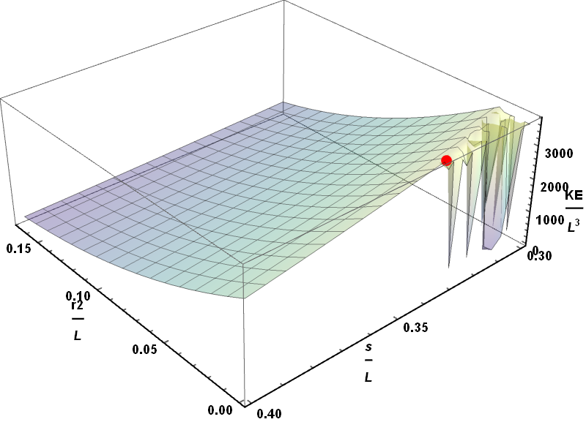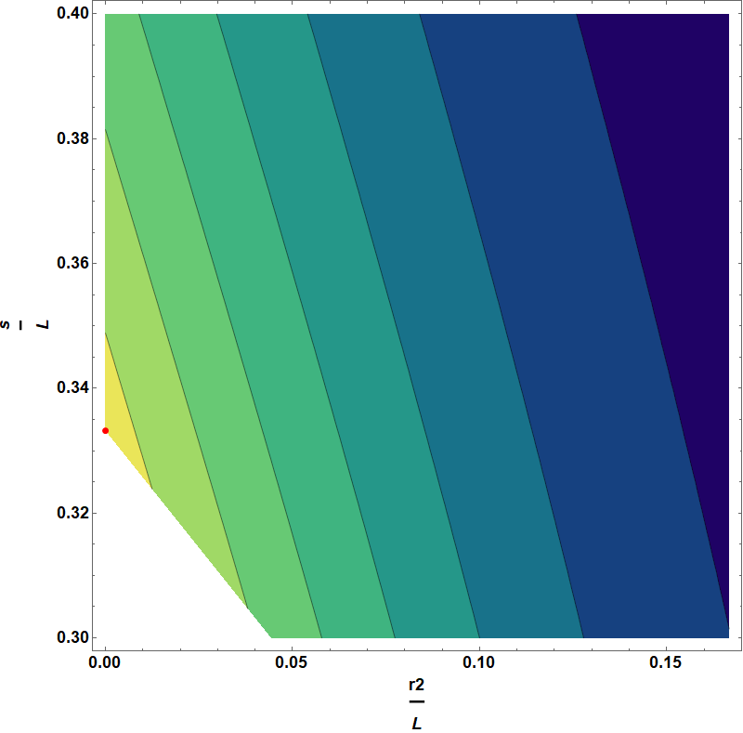

Figure 4.5 (a) Plot of Vs Vs , (b) Contour Plot for Vs , (c) Plot of Vs Vs and (d) Contour Plot forVs . While is the fired ball radius, is the fired millirobot in the first stage radius and is the second

(c) (d)

Figure 4.5 shows the 3D plot and the contour plot for Vs *s/L* Vs *r2/L* and 3D plot and the contour plot for Vs *r/L* Vs *r1/L.*

|  |  |  |  |  |  |
| --- | --- | --- | --- | --- | --- |
|  |  |  |  |  |  |
|  |  |  | 0.0000665578 |  |  |

Table 4.2 Shows the red points values in Figure 4.4.

From Figure 4.4 and Table 4.2 you can notice that the maximum occurred when the fired millirobots and the first millirobots radii maximized and the delivery part minimized with large spacer value. Optimization result from the different radii is greater than twice optimization result from the case when all radii are the same.

In Table 4.3 are the optimum values for and when , while *r* is the fired ball radius, *r1* is the first millirobot in the first stage radius, *r2* is the second millirobot in the first stage radius, *r3* is the first millirobot in the second stage radius, *r4* is the second millirobot in the second stage radius.

|  |  |  |  |  |  |  |  |  |
| --- | --- | --- | --- | --- | --- | --- | --- | --- |
|  |  |  |  |  |  |  |  |  |
|  |  |  | 0.0785 |  |  | 0.066 | 0.112 |  |

Table 4.3 Shows the optimum values for *r, r*1*, r*2*, r*3*, r*4*, s, a* and *KE* when *L=1*.

Table 4.3 shows that by not restricting the radii to be the same, KE = 1019.2 J which is about three times KE when there is a restriction to the radii to be the same.

Figure 4.6 shows the optimized one stage Gauss Gun with different radii and the optimized two stages Gauss Gun with different radii.

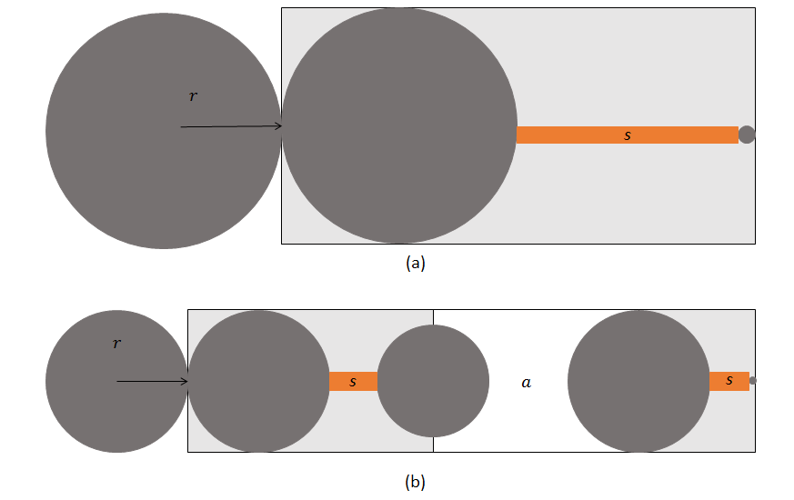

Figure 4.6 (a) one stage optimum MRI Gauss Gun with different radii case and (b) two stages optimum MRI Gauss Gun with different radii case.

## 4.3 Study Cases

Using the results from section 4.2, in this section, we will use these results to apply them in real situations where we are using them to deliver the drug or remove clot from the body for different areas.

### 4.3.1 Study Case 3: Designing MRI Gauss Gun for brachytherapy delivery in the bladder (limited radius size to insert each component, very large area to assemble).

The bladder is a hollow muscular, and distensible (or elastic) organ that sits on the pelvic floor. Urine enters bladder via the ureters and exits via the urethra [25].

In this study case, the MRI Gauss Gun components will enter the bladder through the urethra for brachytherapy delivery for a tumor recovery. In this case, urethra radius and the bladder length are the restrictions. The urethra diameter between 8 – 9 mm [26] and the bladder can be stretched from two inches to 6 inches [27] which is from 5.08 cm to 15.24 cm.

Here will use the average urethra radius 4.25 mm as the radius restriction, the average bladder length 10.16 cm as the MRI Gauss Gun length restriction and the last restriction is the brachytherapy seed radius which is 0.4 mm and that represents the delivery part in the MRI Gauss Gun.

Using Nelder Mead method in Mathematica software we got the optimum values as the code in Figure 4.9. Nelder Mead method gives to get = 0.154 J.

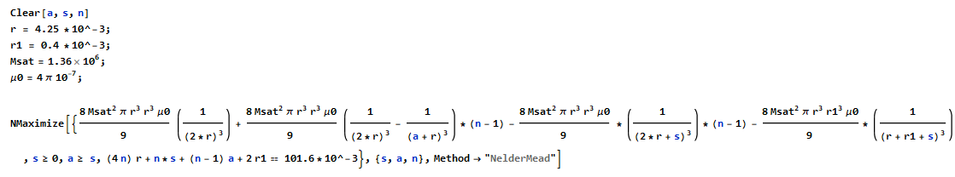

Figure 4.7 Mathematica code to find the optimum value for and to optimize

Figure 4.8 shows the Optimized MRI Gauss Gun to fit inside the bladder and figure 4.9 shows the MRI Gauss Gun inside the bladder.

Figure 4. 8 Optimized MRI Gauss Gun to fit inside the bladder

.



Figure 4.9 Shows the MRI Gauss Gun inside the bladder

### 4.3.2 Study Case 2: Designing MRI Gauss Gun for cyst fenestration in brain ventricle, entry through the spinal canal.

This study case will show how to use the MRI Gauss Gun to deliver a drug to the brain ventricle by entering through the spinal canal. Knowing that a millirobot designed to fit through a 2.5 mm channel could navigate the side or posterior subarachnoid spaces in about 50% of the population, while the device that designed to fit through 1.5 mm channel would fit in more than 85% of the population. Gaining access to the ventricles of the brain from the spine is accomplished by passing through the cerebral aqueduct [27].

From another study, they found that the length for the lateral ventricle’s size depends on the age and gender as the following Table4.4 [28].

|  |  |  |
| --- | --- | --- |
| Age | Length (mm) for Males | Length (mm) for females |
| 15 – 30 | 28.05 2.1 | 27.6 1.7 |
| 31 – 50 | 31.7 2.3 | 28.0 1.7 |
| 51 – 70 | 32.5 2.3 | 30.05 2.0 |

Table 4.4 CT scan measurements (mean standard deviation) of frontal horn of lateral ventricle. https://www.researchgate.net/publication/268449358_Age-related_changes_in_ventricular_system_of_brain_in_normal_individuals_by_computed_tomography_scans

Here will use the millirobot radius to be 0.75 mm for each component as a radius restriction to fit more than 85% of the population, for lateral ventricles this study will show the MRI Gauss Gun for two situations male and female in the age range 31 – 50 as in Table 4.4 as the MRI Gauss Gun length restriction and the last restriction is the brachytherapy seed radius which is 0.4 mm and that represents the delivery part in the MRI Gauss Gun.

#### 4.3.2.a: Case 1 Length restriction using male lateral ventricle length

This case uses = 31.7 mm, r = 0.75 mm and delivery millirobot radius = 0.4 mm. Using Nelder Mead method in Mathematica software we got the optimum values as the code in Figure 4.10. Nelder Mead method gives to get = 1.25 mJ.

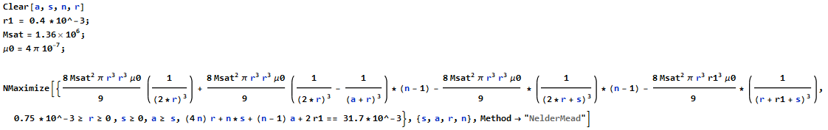

Figure 4.10 Mathematica code to find the optimum value for a,s and N to optimize KE.

#### 4.3.2.b: Case 2 Length restriction using female lateral ventricle length

This case uses = 28 mm, r = 0.75 mm and delivery millirobot radius = 0.4 mm. Using Nelder Mead method in Mathematica software we got the optimum values as the code in Figure 4.10. Nelder Mead method gives to get = 1.18 mJ.

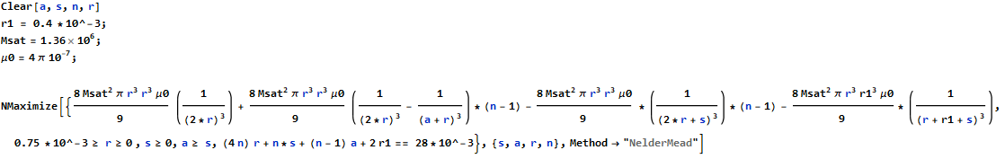

Figure 4.11 Mathematica code to find the optimum value for a,s and N to optimize KE.

For both cases, we have = 4 as in Figure 4.12 and Figure 4.13 show the optimized MRI Gauss Gun and the lateral ventricle respectively.

Figure 4.12 Optimized Gauss Gun with N = 4.

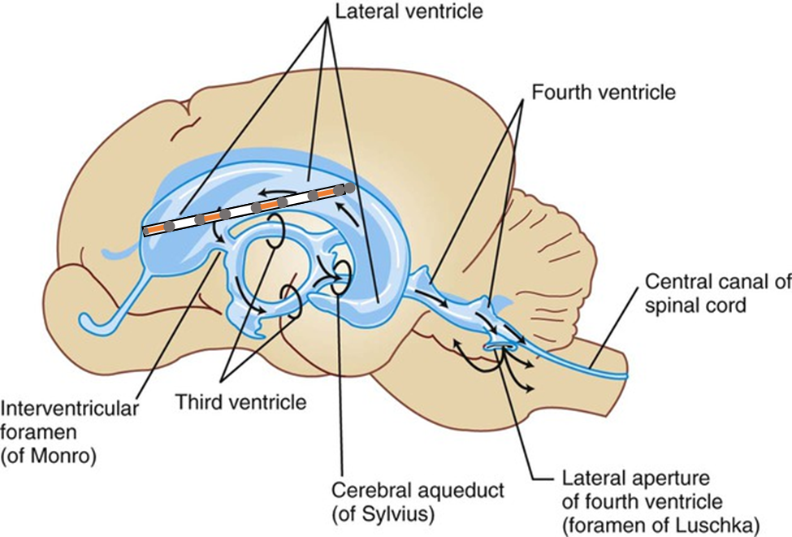

Figure 4.13 Shows the MRI Gauss Gun inside the lateral ventricle https://veteriankey.com/cerebrospinal-fluid-and-the-blood-brain-barrier/.

### 4.3.3 Study Case 3: Designing MRI Gauss Gun for clot removal case from the coronary artery.

In this study case we will show the design for the MRI Gauss Gun to remove the clot from the coronary artery.

To remove a clot from coronary artery we need to let the MRI Gauss Gun components enter the body from an artery from the groin area Figure 4.11 in the leg then navigate them through the Aorta to the left coronary artery Figure 1.4. Knowing that Aorta and the arteries from the groin area are bigger diameters bigger than the coronary which has the smallest diameter between them with 4.6 mm, because of that we will use it as radius restriction, with 1.9 cm length which will be used as restriction [29].

In this study case we will use the radius 2.3 mm as radius restriction and as Length restriction, using Nelder Mead method to optimize to get the optimum

Using the code in Figure 4.10, we will get the following results:

cm, and .

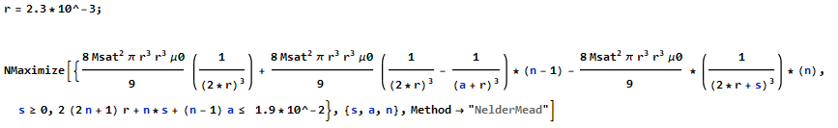

Figure 4.14 Mathematica code to find the optimum value for to optimize .

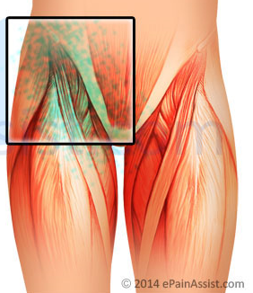

Figure 4.15 Leg groin area. https://www.epainassist.com/pelvic-pain/groin-pain.

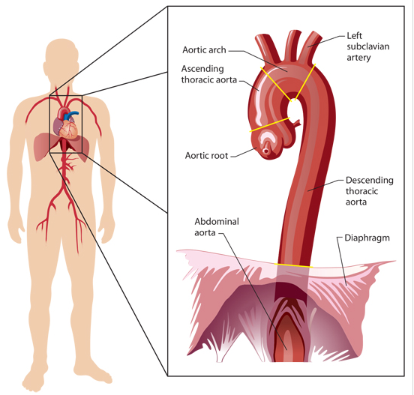

Figure 4.16 Aorta Anatomy. http://www.jems.com/articles/print/volume-41/issue-3/features/how-aortic-aneurysms-become-aortic-catastrophes.html.

Note: using MRI Gauss Gun is not recommended because of the blood flow and in the arteries.

Chapter 5

# **Conclusion**

This thesis presented a model, optimization, and applications for MRI Gauss Gun. The traditional Gauss Gun depends on permanent magnets and steel spheres, while The MRI Gauss Gun can be self-assembled into a larger tool to increase final kinetic energy for the delivery component. The Analysis performed using Nelder Mead method build-in function in Mathematica software to optimize the MRI Gauss Gun with length restriction. Also, this thesis shows potential applications for the MRI Gauss Gun.

Future work will be to implement closed- loop control of the MRI Gauss Gun components.

# **References**

[1] <https://en.wiktionary.org/wiki/millirobot>

[2] R. C. Ritter, M. S. Grady, M. A. H. III, and G. T. Gillies, Computer-integrated Surgery: Technology and Clinical Applications. The MIT Press, 1996, ch. 26 Magnetic Stereotaxis: Computer-Assited, Image-Guided Remote Movement of Implants in the Brain, pp. 363–370.

[3] K. Ishiyama, M. Sendoh, A. Yamazaki, and K. Arai, “Swimming micro-machine driven by magnetic torque,” Sensors and Actuators A: Physical, vol. 91, no. 1, pp. 141–144, 2001.

[4] A. Chanu, O. Felfoul, G. Beaudoin, and S. Martel, “Adapting the clinical MRI software environment for real-time navigation of an endovascular untethered ferromagnetic bead for future endovascular interventions,” Magn Reson Med, vol. 59, no. 6, pp. 1287–1297, Jun. 2008.

[5] P. Vartholomeos, M. Akhavan-Sharif, and P. E. Dupont, “Motion planning for multiple millimeter-scale magnetic capsules in a fluid environment,” in IEEE Int. Conf. Rob. Aut., May 2012, pp. 1927–1932.

[6] P. Vartholomeos, C. Bergeles, L. Qin, and P. E. Dupont, “An MRI-powered and controlled actuator technology for tetherless robotic interventions,” Int. J. Rob. Res., vol. 32, no. 13, pp. 1536–1552, 2013.

[7] A. Becker, O. Felfoul, and P. E. Dupont, “Simultaneously powering and controlling many actuators with a clinical MRI scanner,” in IEEE/RJS International Conference on Intelligent Robots and Systems (IROS), 2014, pp. 2017–2023.

[8] A. Eqtami, O. Felfoul, and P. E. D. E. Dupont, “MRI-powered closed-loop control for multiple magnetic capsules,” in IEEE/RSJ Int. Conf. Intelligent Robots and Systems, 2014, pp. 3536–354.

[9] A. Bigot, C. Tremblay, G. Soulez, and S. Martel, “Magnetic resonance navigation of a bead inside a three-bifurcation pmma phantom using an imaging gradient coil insert,” Robotics, IEEE Transactions on, vol. 30, no. 3, pp. 719–727, June 2014.

[10] W. K. Cho, J. A. Ankrum, D. Guo, S. A. Chester, S. Y. Yang, A. Kashyap, G. A. Campbell, R. J. Wood, R. K. Rijal, R. Karnik, R. Langer, and J. M. Karp, “Microstructured barbs on the north american porcupine quill enable easy tissue penetration and difficult removal,” Proceedings of the National Academy of Sciences, vol. 109, no. 52, pp. 21 289–21 294, 2012. [Online]. Available: http://www.pnas.org/content/109/52/21289.abstract

[11] O. Felfoul, A. Becker, C. Bergeles, and P. E. Dupont, “Achieving commutation control of an MRI-powered robot actuator,” IEEE Trans. on Robotics, vol. under review, 2014.

[12] M. Mahvash and P. Dupont, “Mechanics of dynamic needle insertion into a biological material,” Biomedical Engineering, IEEE Transac-tions on, vol. 57, no. 4, pp. 934–943, April 2010.

[13] J. A. Rabchuk, “The gauss rifle and magnetic energy,” The Physics Teacher, vol. 41, no. 3, pp. 158–161, 2003.

[14] D. Kagan, “Energy and momentum in the gauss accelerator,” The Physics Teacher, vol. 42, no. 1, pp. 24–26, 2004.

[15] R. Schill, “General relation for the vector magnetic field of a circular current loop: a closer look,” Magnetics, IEEE Transactions on, vol. 39, no. 2, pp. 961–967, Mar 2003.

[16] A. T. Becker, “Optimizing a Gauss Gun, Wolfram Demonstrations Project,” Oct. 2014. [Online]. Available: http://demonstrations. wolfram.com/OptimizingAGaussGun/

[17] C. for Disease Control, Prevention et al., “Gastrointestinal injuries from magnet ingestion in children–united states, 2003-2006,” MMWR: Morbidity and Mortality Weekly Report, vol. 55, no. 48, pp. 1296–1300, 2006.

[18] M. F. Kircher, S. Milla, and M. J. Callahan, “Ingestion of magnetic foreign bodies causing multiple bowel perforations,” Pediatric radiol-ogy, vol. 37, no. 9, pp. 933–936, 2007.

[19] I. Howard, M.A, B. Abkes, M. Ollendieck, M. Noh, R. C. Ritter, and

G. Gillies, “Measurement of the force required to move a neurosurgical probe through in vivo human brain tissue,” Biomedical Engineering, IEEE Transactions on, vol. 46, no. 7, pp. 891–894, July 1999.

[20] O. Felfoul, J.-B. Mathieu, G. Beaudoin, and S. Martel, “In vivo mr-tracking based on magnetic signature selective excitation,” Medical Imaging, IEEE Transactions on, vol. 27, no. 1, pp. 28–35, 2008.

[21]<http://reference.wolfram.com/language/tutorial/ConstrainedOptimizationGlobalNumerical.html>

[22] <https://en.wikipedia.org/wiki/Aorta>

[23] <https://en.wikipedia.org/wiki/Pulmonary_artery>

[24] Igor Paprotny and Sarah Bergbreiter “Small-Scale Robotics from Nano-to-Millimeter-Sized Robotic Systems and Applications”, first international workshop at ICRA 2013, Karlsrihe, Germany, May 6, 2013, Revised and Extended Papers

[25] <https://en.wikipedia.org/wiki/Urinary_bladder>

[26] [www.jpma.org.pk/full_article_text.php?article_id=5590](http://www.jpma.org.pk/full_article_text.php?article_id=5590)

[27] <https://www.healthline.com/human-body-maps/bladder>

[28] <https://www.researchgate.net/publication/268449358_Age-related_changes_in_ventricular_system_of_brain_in_normal_individuals_by_computed_tomography_scans>

[29] <http://www.onlinejacc.org/content/11/3/565>

[30] https://en.wikipedia.org/wiki/Autoinjector